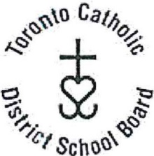
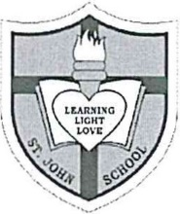

ST. JOHN CATHOLIC SCHOOL
780 Kingston Road Toronto, Ontario, M4E 1R7
Telephone: 416-393-5220 Fax: 416-393-5211

Please fill out this form to request a refund for the pizza lunches that CSPC were unable to provide due to Covid-19. If you prefer not to request a refund, your payment will gladly be accepted by CSPC and will be included for future CSPC initiatives for the school.

Please fill out and email to: claire.oshea@hotmail.com

Name of student_____________________________

Grade/PM teacher____________________________

# of pizza lunches not received due to school closure__________

# of pizza slices ordered______type_____________ (cheese/pepperoni/daiya/gluten free)

# snacks ordered____

Name to be written on the refund cheque_________________________

Address where the cheque should be mailed_______________________

