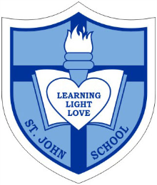

Catholic School Parent Council Agenda
ANNUAL GENERAL MEETING

Date Wednesday, September 21st, 2016
Timing 7:30PM-8:30PM
Location St. John Catholic School

7:30pm-7:35pm Opening Prayer: Ms. Horbay

7:35pm-7:40pm Welcome and passing of June 2016 meeting minutes: Corbin Tomaszeski

7:40pm-7:50pm 2015/16 year-end financial report with opening balance for new council: Greg Chow and Vivianne Rankin

7:50pm-7:55pm 2015/16 Fundraising and Special Events Year-end Report: Marianne Internicola, Nadia Niccoli and Jacky Arminen

7:55pm-8:00pm 2015/16 Sponsorship and Grants Report – Claire O’Shea and Jacky Arminen

8:00pm-8:10pm Principal Report- Anne Martin

8:10pm-8:20pm 2015/16 CSPC Chairman Report: Corbin Tomaszeski
2015/16 CSPC uploads and updates to website: Vivianne Rankin

8:20pm-8:30pm Q & A

8:30pm Closing Prayer: Ms. Horbay

8:30pm-8:45pm Elections Update- Elections Committee
New 2015/16 CSPC to meet and determine positioning assignments and responsibilities of new members

I appeal to you, brothers and sisters, in the name of our Lord Jesus Christ,
that all of you agree with one another in what you say and that there be no divisions among you,
but that you be perfectly united in mind and thought.
1 Corinthians 1:10

