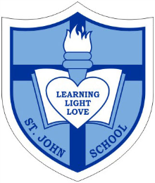
Catholic School Parent Council Meeting

Date: Wednesday, June 15, 2016
Timing: 7:00PM-8:30PM
Location- St. John Catholic School

7:00pm-7:05pm Welcome: Corbin Tomaszeski

7:05pm-7:10pm Opening Prayer: Ms. Brault

7:10pm-7:15pm Review and Approval of Previous Meeting Minutes: Sharon Smyl

7:15pm-7:25pm St. John Principal’s Report :Vice Principal Ms. Jennifer Brault

7:25-pm-7:35pm Fund-Raising “Spring Carnival Update”: Nadia Niccoli, Marianne Internicola, Jeanette Cole and Mary Lagonia

7:35pm-7:40pm Special Events Update -Graduation: Jacky Arminen

7:40pm-7:50pm Church and Community: Carmen Vanderreest

7:50pm-8:00pm Treasurer Report- Review Financial Statement and CSAC Cash Flow as well as approval of statements: Greg Chow and Vivanne Rankin

8:00pm-8:10pm Outdoor Space and Board Space- Ms. Brault and Corbin Tomaszeski

8:10pm-8:30pm Discussion on Spend of excess funds for 2015/16- categories of Music/ Arts/ IT and Scholastic initiatives and or programs: All CSPC Members

8:30pm Closing Remarks and Next Meeting Date(s): Corbin Tomaszeski

8:30pm Closing Prayer: Ms. Brault

