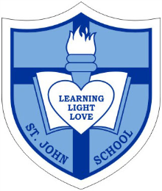
Catholic School Parent Council Agenda

Date Thursday, January 19, 2017
Timing 7:30PM-8:45PM
Location St. John Catholic School

7:30pm Opening Prayer - Ms. Horbay

7:30pm-7:35pm Welcome - Corbin Tomaszeski and Kim Cho

7:35pm-7:40pm Sponsorship and Grants Report - Claire O’Shea and Jacky Arminen

7:40pm-7:50pm Fundraising Update (to include upcoming events)- Nadia Niccoli, Jenny Gafney, Tanya Bismayer
and Megan Wise

7:50pm-8:00pm Financial Review- Vivianne Rankin

8:00pm-8:10pm Special Events and Volunteer Update – Jacky Arminen, Claire O’Shea,
Michael Teixera and Angela Visconti

8:10pm-8:15pm Parish Updates- Carmen /Vandeerest and Lynn Lospinuso

8:15pm-8:20pm Website and Communications Update- Lyne McMurchie

8:20pm-8:35pm Principal Report – Ms. Anne Martin

8:35pm-8:40pm OAPCE Update- Rosa Morphy

8:40pm-8:45pm Next Meeting, Save the Dates and Q & A – Corbin Tomaszeski and Kim Cho

8:45pm Closing Prayer: Ms. Horbay

