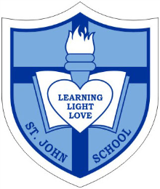

Catholic School Parent Council Meeting

Date: Wednesday, October 7, 2015
Timing: 7:00PM-8:40PM
Location- St. John Catholic School

7:00pm-7:35pm Opening Prayer: Student Council Representative

7:35pm-7:40pm Welcome Remarks to CSAC’s “Year of Communication”: Corbin Tomaszeski

7:40pm-7:45pm CSAC Member Introductions and Responsibilities: Jacky Arminen

7:45pm-8:00pm St. John Principal’s Report: Principal Ms. Anne Martin & Vice Principal Ms. Jennifer Brault

8:00pm-8:10pm Fund-Raising Update – will speak to this school year’s 3 Revenue Events: Nadia Niccoli and Marianne Internicola

8:10pm-8:25pm Treasurer Report- present the Finance Meeting Budget Proposal and Financial Statement and CSAC Cash Flow: Greg Chow

8:25pm-8:35pm Update on Grants and Special Events- Jacky Arminen and Claire O’Shea

8:35pm Closing Remarks and Next Meeting Date(s): Corbin Tomaszeski

8:40pm Closing Prayer: Student Council Representative

Each of us has a vision of good and of evil.
We have to encourage people to move towards what they think is good...
Everyone has his own idea of good and evil and must choose to follow the good and fight evil as he conceives them.
That would be enough to make the world a better place.
Pope Francis

