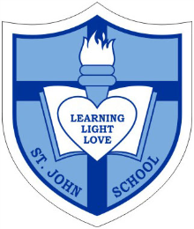
Catholic School Parent Council Meeting

Date: Wednesday, November 25, 2015
Timing: 7:00PM-8:30PM
Location- St. John Catholic School

7:00pm-7:05pm Introduction of Student Council Representative: Corbin Tomaszeski

7:05pm-7:10pm Opening Prayer: Student Council Representative

7:10pm-7:20pm Group Introductions with new attendees, CSPC Updates, Council Member status, Council Responsibilities: Corbin Tomaszeski

7:20pm-7:25pm Review and Approval of October’s Meeting Minutes: Sharon Smyl

7:25pm-7:40pm St. John Principal’s Report: Principal Ms. Anne Martin & Vice Principal Ms. Jennifer Brault

7:40pm-7:50pm Fund-Raising Update: Nadia Niccoli and Marianne Internicola

7:50pm-8:00pm Treasurer Report- Review Financial Statement and CSAC Cash Flow as well as approval of statements: Greg Chow

8:00pm-8:05pm Update Special Events- to include 2016 confirmation, Christmas Bake Sale etc.- Special Events Team

8:05pm-8:10pm Update on Grants and Donations: Jacky Arminen and Claire O’Shea

8:10pm-8:25pm Church and Community Update: Carmen Vanderreest

8:25pm-8:30pm Closing Remarks and Next Meeting Date(s): Corbin Tomaszeski

8:30pm Closing Prayer: Ms. Horbay

Therefore the Lord himself will give you a sign: The virgin will be with child and will give birth to a son,
and will call him Immanuel.

Isaiah 7:14

