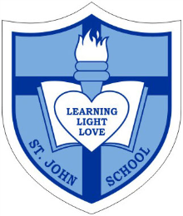
Catholic School Parent Council Meeting

Date: Wednesday, February 3, 2016
Timing: 7:00PM-8:35PM
Location- St. John Catholic School

7:00pm-7:05pm Welcome: Corbin Tomaszeski

7:05pm-7:10pm Opening Prayer: Student Council Representative

7:10pm-7:15pm Review and Approval of Previous Meeting Minutes: Sharon Smyl

7:15pm-7:35pm St. John Principal’s Report (to include recent Update from the Board on Playground revitalization, Update on Approved Monies Spend and School Vote on 2015/16 Christmas Break: Principal Ms. Anne Martin & Vice Principal Ms. Jennifer Brault

7:35pm-7:45pm Fund-Raising Update- to include “Out all Night Social Event”, “Read-a-thon” and “Spring Carnival”: Nadia Niccoli, Marianne Internicola, Jeanette Cole and Mary Lagonia

7:45pm-7:55pm Special Events Update- to include, Confirmation, First Communion and Graduation: Claire O’Shea, Cate Gaudet and Jacky Arminen,

7:55pm-8:00pm Volunteerism Update- to include support for fund-raisers, special events and pizza lunches Michael Teiexeira and Jennie Gaffney

8:00pm-8:10pm Treasurer Report- Review Financial Statement and CSAC Cash Flow as well as approval of statements: Greg Chow and Vivanne Rankin

8:10pm-8:15pm Update on Grants and Donations: Jacky Arminen and Claire O’Shea

8:15pm-8:25pm Church and Community Update: Carmen Vanderreest

8:25pm-8:30pm Communications and Website Update: Eneida Contreiras

8:30pm -8:35pm Closing Remarks and Next Meeting Date(s): Corbin Tomaszeski

8:35pm Closing Prayer: Ms. Horbay

