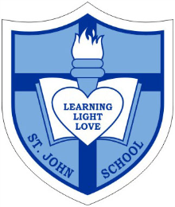
Catholic School Parent Council Meeting

Date: Wednesday, April 27, 2016
Timing: 7:00PM-8:30PM
Location- St. John Catholic School

7:00pm-7:05pm Welcome: Corbin Tomaszeski

7:05pm-7:10pm Opening Prayer: Student Council Representative

7:10pm-7:15pm Review and Approval of Previous Meeting Minutes: Sharon Smyl

7:15pm-7:25pm St. John Principal’s Report Principal Ms. Anne Martin & Vice Principal Ms. Jennifer Brault

7:25-pm-7:40pm Fund-Raising “Spring Carnival Update”: Nadia Niccoli, Marianne Internicola, Jeanette Cole and Mary Lagonia

7:40pm-7:50pm Special Events Update- to include, Confirmation, First Communion Recap and Graduation: Jacky Arminen,

7:50pm-8:00pm Church and Community Update to include- confirmation and other church initiatives and activities: Carmen Vanderreest

8:00pm-8:10pm Treasurer Report- Review Financial Statement and CSAC Cash Flow as well as approval of statements: Greg Chow and Vivanne Rankin

8:10pm-8:20pm Communications and Website Update: Eneida Contreiras and Carmelina Totten

8:20pm-8:30pm Open Q & A

8:30pm Closing Remarks and Next Meeting Date(s): Corbin Tomaszeski

8:30pm Closing Prayer: Ms. Horbay

